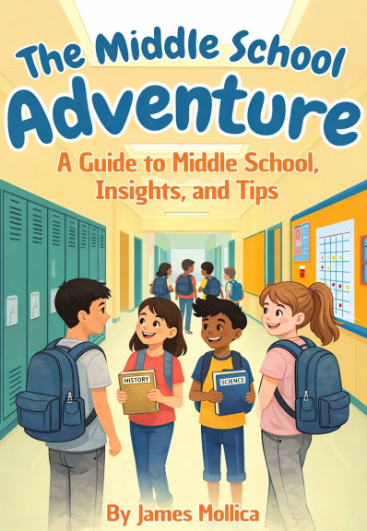

Table of Contents
Introduction ii
Chapter 1: Making New Friends 1
Chapter 2: Balancing New and Old Friendships 4
Chapter 3: Step Out of Your Comfort Zone and Try New Things 7
Chapter 4: Get Involved in After-School Activities 10
Chapter 5: Be Assertive and Advocate for Yourself 13
Chapter 6: Limit Your Time on Social Media 16
Chapter 7: Take Responsibility for Your Own Actions 19
Chapter 8: It’s Okay to Say “No” to Peer Pressure 22
Chapter 9: Asking Yourself…“Will My Family, Friends, or Loved Ones Be Proud of Me After I Make This Decision?” 25
Chapter 10: Stay True to Yourself 28
Chapter 11: The Art of Time Management 31
Chapter 12: Learning to Stay Organized 34
Chapter 13: Be Open to Criticism or Feedback 37

The Guide to Creating a Successful Middle
School Experience:

Introduction
Welcome to middle school! This year marks the beginning of an exciting new chapter in your life, filled with opportunities and adventures. Entering middle school with an open mind and an open heart will help you make the most of this transformative time.
Middle school is a time of growth and discovery. You will have the opportunity to explore new subjects, join a variety of activities, and make new friends. It is a journey in which you will learn more about yourself, your interests, and your abilities. Embrace these opportunities to challenge yourself, step outside your comfort zone, and try new things.
In this guide, we will walk you through what to expect in middle school and offer tips on how to navigate this important stage of your life. From making friends and getting involved in after-school activities to managing your time wisely and staying organized, this guide is designed to help you thrive during your middle school years.
Remember, middle school is not just about academics; it is also about personal growth and building character. Be open to feedback, stay true to yourself, and do not be afraid to stand up for what you believe in. Your middle school experience is what you make of it, so take every opportunity to learn, grow, and enjoy the journey.
Welcome to Middle School. Let's make it an amazing adventure!
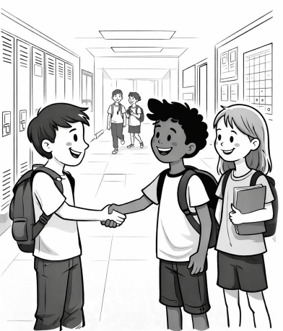

Chapter 1: Making New Friends
(Even If It Feels a Little Awkward at First!)
Entering middle school is a great opportunity to meet new people. Think of it like starting a new season of your favorite show — same main character (you), but a whole new cast you haven’t met yet. Be open to making friends with classmates you haven't talked to before. Join conversations, jump into group activities, and show genuine interest in others. Remember, everyone is secretly hoping someone will talk to them too… even the kid who looks like they already have their whole life together.

Why Making New Friends Is Important
Having a good group of friends can make school more enjoyable and a lot less stressful. Friends provide support, share interests, and help you feel connected. They can encourage you to try new things, cheer you on, and occasionally remind you when you’ve got marker on your face. Good friends help you grow — and sometimes help you grow your snack stash.

Tips for Making New Friends

Be Open and Approachable
Smile and Make Eye Contact: A friendly smile goes a long way… just don’t stare too long, or people might wonder if you forgot how blinking works.
Body Language: Sit or stand with an open posture. Avoid crossing your arms — it can make you look like you’re guarding the last slice of pizza.

Join Clubs and Activities
Find Your Interests: Sports, music, art, science, robotics, drama — there’s something for everyone. Yes, even if your main hobby at the moment is “being mildly confused.”
Participate Actively: Show up regularly. The more you participate, the more people will get to know you.

Start Conversations
Common Interests: Start with topics you both enjoy, like movies, books, games, or which cafeteria food is the least suspicious.
Ask Questions: People love talking about themselves — it’s practically a human superpower.
Share About Yourself: Don’t be afraid to talk about your own interests. You never know who secretly loves the same weird show you do.

Be Kind and Inclusive
Include Others: If you see someone sitting alone, invite them to join you. One small act of kindness can turn someone’s whole day around.
Be Supportive: Encourage your friends, cheer them on, and celebrate their successes — even if they beat you in gym class… again.

Handle Rejection Positively
Stay Positive: Not everyone will want to be your friend, and that’s okay. Some friendships just aren’t meant to be.
Learn and Move On: If someone doesn’t click with you, take it as a learning moment, not a disaster. There are plenty of other people waiting to meet you.

Be Yourself
Authenticity: Be true to who you are. Pretending to be someone else is exhausting — and you’re pretty awesome as-is.
Confidence: Believe in yourself. Confidence is like an invisible superpower cape — no one sees it, but everyone notices it.
Being open, kind, and genuine will help you build friendships that last. And who knows? One of them might save you a seat at lunch or share their extra cookie.

Conclusion
Making new friends in middle school might feel a little scary at first, but remember—you’re not the only one figuring things out. Everyone is trying to find their people, their place, and maybe someone who laughs at their jokes. By being open, kind, and true to yourself, you’ll create friendships that make middle school not just easier, but way more fun. And sometimes, those friendships can last far beyond the school halls.
So take a deep breath, put yourself out there, and don’t be afraid to say “hi” to someone new. Your future best friend might be standing right next to you…
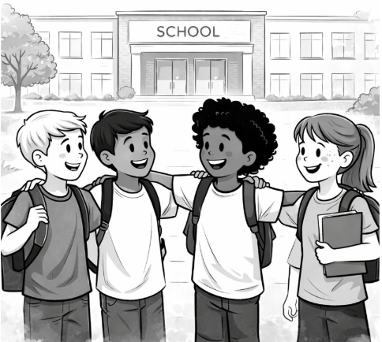

Chapter 2: Balancing New and Old Friendships
Starting middle school is an exciting journey, full of new opportunities, new faces, and maybe even a cafeteria smell you’ll never quite forget. One of the biggest changes is meeting new people and making new friends. But here’s the good news: making new friends doesn’t mean you have to ditch your old ones like last year’s backpack. True friends stick with you—just like glitter. No matter how much life changes, they’re still there. Balancing both new and old friendships gives you a richer, more interesting social life (and more birthday party invites).

Why It Is Important to Maintain Old Friendships

Stability and Comfort
Old friends give you a sense of comfort—like your favorite hoodie that you refuse to throw away, even though it has a few mysterious stains. They already know your likes, dislikes, and the fact that you absolutely cannot function before 8 a.m. This familiarity can be reassuring during the adventure known as middle school. When everything feels new, your old friends are the people who remind you that you’re still you.

Shared History
With old friends, you share memories, inside jokes, and possibly a few embarrassing moments you’ve all agreed never to mention again. These shared experiences build a strong bond that’s hard to replace. Your old friends understand where you’ve been, which makes facing new challenges much easier—like when you get lost on the way to third-period Spanish and they pretend they aren’t judging you.

The Benefits of Making New Friends

Broadening Horizons
New friends can open your world to new perspectives, activities, and hobbies—maybe even convince you to try something wild, like joining the chess club or eating the cafeteria’s “mystery meat” (proceed with caution). Meeting people with different backgrounds helps you grow and see the world in new ways.

Expanding Your Social Network
The more friends you make, the more people you have to turn to for support, advice, homework help, or simply someone to sit with at lunch when your usual squad is out sick. Different friends play different roles—study buddy, soccer teammate, or meme-sharing champion. A diverse group helps you develop a wide range of social skills, including how to navigate and avoid drama. (A crucial middle school survival skill!)

Balancing New and Old Friendships

Communication Is Key
Maintaining friendships—old and new—takes consistent communication. Check in with your old friends, even as you’re meeting new people. Send a message, share a funny story, or remind them that, yes, you still exist. Let them know they’re important, even if you now sit near someone in math class who also loves the same weird YouTube videos.

Include Everyone
When you can, try to mix your friend groups, invite both old and new friends to hang out, join a study group, or eat lunch together. Who knows? Your childhood bestie and your new lab partner might become friends too. Or at least they won’t give each other the “who’s this stranger?” stare, which is progress.

Manage Your Time
Having multiple friendships means learning how to manage your time—kind of like juggling, but with fewer flying objects. Make an effort to spend time with both old and new friends. Nobody wants to feel forgotten (unless they’re hiding during dodgeball—then yes, forget them). Setting aside time shows appreciation for everyone in your circle.

The Qualities of True Friends

Understanding and Support
True friends understand that making new friends doesn’t replace them. They want you to grow, meet new people, and genuinely be happy. They know your bond is strong—strong enough to survive different classes, new routines, and even the betrayal of you liking a new snack better than the one you always shared.

Flexibility and Patience
Middle school schedules can be chaotic—you might have band practice, homework, projects, sports, or just the daily exhaustion of being a human being. True friends understand that you can’t always hang out. They’re patient, flexible, and know your friendship is strong enough to handle busy moments without falling apart.

Conclusion
Balancing new and old friendships is one of the secrets to enjoying middle school. Making new friends doesn’t mean leaving old ones behind. True friends remain steady, supportive, and understanding—even as your social circle grows. By communicating, including others, and managing your time wisely, you can build a strong, diverse, and drama-resistant friend group that helps you thrive. Middle school is a lot more fun (and a lot less awkward) when you have a solid mix of old memories and new adventures—plus a few friends who will remind you when you’ve got food on your face.
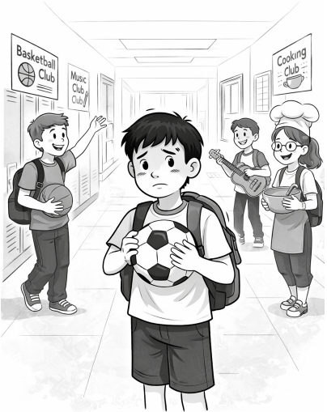

Chapter 3: Step Out of Your Comfort Zone and Try New Things
Middle school is a time of major change, growth, and discovering that you now have about six different hallways to get lost in. One of the most important lessons during this period is learning to step out of your comfort zone and try new things. Sure, staying in your comfort zone feels safe—like wearing the same hoodie every day—but taking small risks can lead to exciting opportunities, new friendships, and maybe even discovering a hidden talent you didn’t know you had (like juggling… or realizing you cannot juggle, and that’s okay too). Embracing new experiences builds confidence and resilience, and makes your middle school story much more interesting.

The Importance of Stepping Out of Your Comfort Zone

Personal Growth
When you step out of your comfort zone, you push yourself to grow—kind of like leveling up in a video game. You learn problem-solving, adaptability, and how to bounce back when things don’t go exactly as planned. These challenges help you realize you’re capable of far more than you thought.

Overcoming Fear
Trying something new often means facing fears—fear of failing, fear of being judged, or fear of the unknown. But the more you practice stepping outside your comfort zone, the easier it becomes.

Discovering New Talents and Interests

Uncover Hidden Abilities
You might surprise yourself with what you can do once you try. Maybe you’ll discover you’re amazing at drawing, drumming, or coding—or maybe you’re the world’s fastest locker-opener. Trying new things introduces you to talents you didn’t know you had, which can boost confidence—and maybe even make you the go-to class expert for something cool.

Broadening Your Horizons
Exploring new activities helps you see the world in fresh ways. Whether you try a sport you’ve never heard of or a club you didn’t know existed (like Origami Club… yes, that’s a thing!), you’ll experience perspectives that make your life richer and more interesting.

Building Connections and Friendships

Meeting New People
Joining new groups—clubs, teams, or after-school activities—helps you meet people you might not have crossed paths with otherwise. These people may become study buddies, teammates, or best friends who laugh with you, cheer for you, and occasionally remind you that your backpack is still unzipped.

Enhancing Social Skills
Trying new things also develops communication and teamwork skills. You’ll learn how to collaborate, share ideas, and handle awkward moments (like saying “you too” when someone tells you “good luck on your test”). These social skills help you in school, friendships, and life.

Embracing New Opportunities

Academic and Career Benefits
Trying new activities might lead you to future passions. Maybe the science club sparks an interest in engineering, the school newspaper introduces you to writing, or the drama club helps you discover your inner superstar. You never know—a single new experience could shape your future career… or at least give you something cool to put on applications.

Personal Fulfillment
Even if you don’t become amazing at everything you try (spoiler: nobody does), each experience adds to your story. Stepping out of your comfort zone brings a sense of accomplishment—kind of like finishing a really tough level in a game. It feels great, and it builds confidence for the next challenge.

Tips for Stepping Out of Your Comfort Zone

Start Small
You don’t have to make giant leaps. Baby steps count! If starting conversations scares you, try saying “hi” to one new person. If new activities feel overwhelming, attend just one meeting. Small steps add up.

Embrace Failure
Failure is perfectly okay. It’s how you learn! Think of it like riding a bike: almost everyone falls the first time, probably the second… and maybe the third. What matters is getting back up and trying again. Each time you stumble, you learn something new.

Seek Support
Friends, family, and teachers can offer encouragement and advice. Having a support team makes every new experience a little easier. Plus, cheering squads are always fun—even if it’s just one friend clapping loudly as motivation.

Reflect on Your Experiences
Take a moment to think about what you’ve tried and what you’ve learned. Journaling is a great way to track your progress, celebrate wins, and laugh at the moments that didn’t go quite as planned. Reflection helps you see how far you’ve come—and inspires you to keep going.

Conclusion
Stepping out of your comfort zone and trying new things is one of the best ways to grow, discover hidden talents, and build amazing connections. Middle school offers countless opportunities—some exciting, some nerve-wracking, and some that might involve wearing a silly costume for a club you joined on a dare. No matter what happens, each experience adds to your journey and helps you become stronger, braver, and more confident. Embrace new opportunities, take risks, and remember: even if things don’t go perfectly, you’re learning, growing, and creating a pretty awesome story.
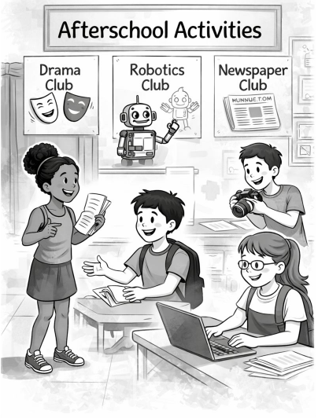

Chapter 4: Get Involved in After-School Activities
Entering middle school is exciting, confusing, and sometimes feels like you’ve just landed on a new planet where everyone already knows the secret rules—like how to open your locker on the first try. One of the best ways to make this new world feel more familiar is by getting involved in after-school activities. Whether it’s extra help, clubs, or sports, these activities turn middle school from “just someplace you attend” into an experience you actually enjoy—yes, that’s possible!

Why Get Involved in After-School Activities?

Sense of Belonging
After-school activities help create a sense of belonging. When you join a club, team, or group, you become part of a community with shared goals, inside jokes, and occasionally matching T-shirts. Suddenly, school feels less like a maze and more like a place where people actually know your name.

Building Friendships
You’ll meet new people who enjoy the same things you do—whether that’s robotics, basketball, or crafting miniature clay animals for no reason whatsoever. Working together builds friendships that make your days brighter, your conversations livelier, and your group projects way more bearable.

Academic and Personal Growth

Extra Help Sessions
Believe it or not, extra help sessions are not punishment. They’re actually a superpower in disguise. Teachers can help you understand tricky material, raise your grades, and prevent that “uh-oh” feeling before a test. It’s basically academic magic—minus the wand and sparkles.

Developing New Skills
Clubs and sports help you build real-life skills like teamwork, leadership, time management, and learning not to cry when you lose a game (it happens). Debate club sharpens your public speaking, and sports can teach discipline and resilience—plus you get the bonus of occasionally running around like you have endless energy.

Enhancing the Middle School Experience

Exploring Interests
Always wanted to try drama? Art? Science Club? Chess? There’s an after-school activity for just about everything. This is your chance to discover new passions—or at least try something once and say, “Okay… maybe not for me,” which is still valuable.

Building a Well-Rounded Resume
Believe it or not, high schools and colleges like it when students have a mix of interests. Joining different activities shows you’re not just sitting around watching YouTube all day (even if you sometimes still do).

Emotional and Social Benefits

Stress Relief
After-school activities help you unwind. Sports release endorphins (fancy word for “happy chemical”), and creative clubs help your brain relax. So yes—drawing a dinosaur, kicking a soccer ball, or playing the ukulele counts as stress management.

Building Confidence
Scoring a goal, performing on stage, or finally mastering that stubborn math problem all give you confidence boosts. These moments remind you that you’re capable of awesome things.

Practical Tips for Getting Involved

Explore Your Options
Go to club meetings, talk to teachers, and see what your friends are doing. And don’t worry—nobody expects you to immediately know your life’s passion at age 11. Try stuff. Have fun. It’s like sampling ice cream flavors.

Manage Your Time Wisely
Activities are great, but so is remembering to finish your homework. Use a planner, calendar, or even a reminder app to balance everything. Future you will thank the present you.

Commit and Stay Engaged
Show up. Participate. Bring your best attitude. You’ll get more out of an activity when you put more into it. Plus, people will notice—and opportunities tend to follow effort.

Conclusion
Getting involved in after-school activities can transform your middle school experience from “meh” to memorable. You’ll make friends, learn new skills, discover interests you never knew you had, and maybe even surprise yourself along the way. So jump in—join that club, try that sport, attend that extra help session. Middle school is a lot more fun when you’re part of something.
And hey, if all else fails, at least you’ll have a great story to tell one day… probably starting with, “So I joined this club once…”



Chapter 5: Be Assertive and Advocate for Yourself
Middle school is a big step—suddenly, you have more teachers, more responsibilities, and a locker that may or may not open on the first dozen tries. One of the most important skills you can learn during this time is how to be assertive and advocate for yourself.
This means speaking up, asking questions, and taking ownership of your learning (instead of letting your parents send emails that start with, “Dear Teacher, my child is confused…”). Teachers love it when students show initiative—it shows maturity, responsibility, and that you’re alert enough to ask a question.

Why Being Assertive Is Important

Taking Control of Your Education
Being assertive helps you take charge of your own learning. It’s like being the captain of your academic ship—minus the eye patch and parrot. When you ask for help early, problems don’t turn into big disasters later. Seriously, one quick question can save you from that “I totally don’t understand this test” panic.

Building Confidence
Every time you speak up—whether it’s asking for clarification or requesting extra help—you’re telling yourself, “I’ve got this.” And guess what? Confidence grows. Before you know it, you’ll be raising your hand without your heart feeling like it just ran a marathon.

How to Be Assertive and Advocate for Yourself

Ask Questions
If something doesn’t make sense, ask. The only bad question is the one you keep locked in your brain, where it can do nothing but confuse you. Teachers are basically superheroes whose power is explaining things—let them use it!
(And no, they won’t think you’re annoying. I promise.)

Seek Advice
Not sure which class to take? Feeling overwhelmed? Wondering why your locker hates you? Talk to the adults around you—teachers, counselors, administrators. They’ve seen it all, heard it all, and survived middle school themselves. They know things.

Speak Up in Class
Sharing your thoughts in class shows that you’re paying attention and engaged… even if you were half convinced the teacher called on someone else. Participating helps you learn more, and it gives teachers a good feeling too.

Set Goals and Communicate Them
Setting goals gives you direction—like telling yourself, “This is the year I will not lose my homework in the mysterious void of my backpack.”
If your teachers know your goals, they can help you achieve them. They’re rooting for you, even on days you forget your pencil.

Benefits of Being Assertive

Improved Academic Performance
When you ask for help, you understand things better. And when you understand things better, you do better.

Stronger Relationships with Teachers
Teachers remember students who participate, ask questions, and take initiative. It makes you stand out—in a good way, not the “I just dropped all my supplies in the hallway again” way.

Enhanced Problem-Solving Skills
Self-advocacy teaches you how to identify problems, brainstorm solutions, and take action. This skill will help you in school, friendships, sports, and basically every part of life—except maybe picking what to eat for lunch; that’s always a struggle.

Tips for Developing Assertiveness

Practice Self-Reflection
Think about what you need help with, what you’re doing well, and where you want to improve. It’s like checking your internal GPS to see if you’re heading in the right direction—or if you need to “recalculate the route.”

Use “I” Statements
Instead of blaming or sounding frustrated, use statements like:
“I feel confused about…”
“I need help with…”
This keeps the conversation positive and shows you're taking responsibility (very adult-like of you!).

Stay Calm and Respectful
Being assertive isn’t about being loud—it’s about being clear and respectful. You want people to listen, not run away.

Practice in Safe Environments
If speaking up feels scary at first, practice with someone you trust. Role-play conversations with a friend, parent, or even a very supportive pet.

Conclusion
Learning to be assertive and advocate for yourself is one of the greatest gifts you can give your future self. It helps you take control of your education, build confidence, and face challenges head-on. Teachers and administrators value students who communicate clearly, ask questions, and seek help when needed—it shows responsibility and maturity.
By practicing assertiveness now, you’re setting yourself up for a stronger, more successful, and more confident middle school experience. So speak up, take charge, and remember: your voice matters—even if it sometimes cracks mid-sentence.
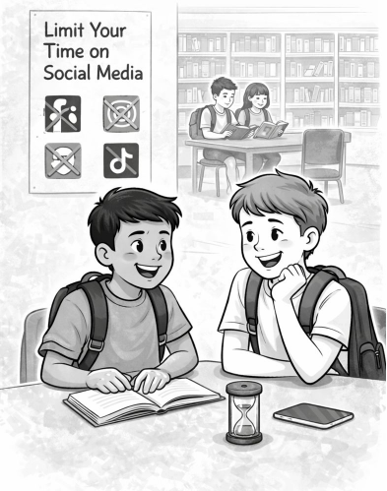

Chapter 6: Limit Your Time on Social Media
Social media is a huge part of modern life—especially in middle school, where a five-second Snapchat streak loss can apparently feel like the end of the world. Yes, these apps can be great for staying connected, making plans, and sharing pictures of your dog wearing sunglasses. But too much social media can mess with your emotions, your sleep, and even your grades.
Finding a healthy balance (meaning: putting the phone down before it feels glued to your hand) can make your middle school years much happier and more fulfilling. Let’s explore why limiting your social media time matters—and how doing so can actually make your life way better.

The Benefits of Social Media

Staying Connected
Apps like Instagram, Snapchat, and TikTok help you keep up with friends and family. You can share moments, send messages, and follow what everyone’s doing—without having to say, “Wait, what happened?” 40 times a day.

Making Plans
Group chats make it easy to plan hangouts, study sessions, or club meetings… as long as someone doesn’t mute the chat and miss all 97 messages.

Finding Information
Social media can teach you things—from homework tips to fun facts. Just make sure the “facts” aren’t coming from someone whose profile bio reads: “Trust me, I’m always right.”

The Negative Effects of Excessive Social Media Use

Impact on Mental Health
Too much scrolling can make you feel anxious, lonely, or like everyone else is living a perfect life while you’re just hunting for matching socks. Constant comparison is exhausting and unfair—it’s like comparing your behind-the-scenes to someone else’s highlight reel.

Disruption of Sleep
Using your phone before bed can make it harder to fall asleep. The blue light from your screen basically tells your brain, “Wake up! Let’s do math!”
And no one wants their brain doing math at 11 p.m.

Decreased Academic Performance
Every hour spent watching TikTok dances is… well… an hour not doing your homework. Social media can turn a quick break into, “How did it become 9:45 already?!”

Enhancing Personal Connections Through Face-to-Face Interactions

Building Stronger Relationships
Talking to people in person (yes, with actual words and facial expressions!) helps build deeper friendships. You can’t always get that from a heart emoji.

Improving Communication Skills
When you interact face-to-face, you practice reading body language, expressing yourself clearly, and not accidentally sending a message to the wrong group chat.

Creating Lasting Memories
You’re way more likely to remember a real adventure with friends than the 500th video of a dancing cat—no matter how adorable it is.

Tips for Limiting Your Time on Social Media

Set Time Limits
Most phones let you track and limit screen time. Think of it as your device saying, “Hey buddy… maybe go touch some grass?”

Schedule "No Screen" Times
Pick certain parts of the day where screens are off-limits—like meals, right before bed, or while doing homework. You’d be surprised how peaceful life is when your phone isn’t dinging every two seconds.

Turn Off Notifications
Turn off the non-important stuff so you’re not constantly tempted to check your phone. Do you really need to know immediately that someone liked your photo from three days ago? Probably not.

Find Alternative Activities
Join a club, try a new hobby, play a sport, or hang out with friends in person. Your life shouldn’t happen through a screen—it should happen around it.

Seeking Balance

Reflect on Your Usage
Ask yourself:
Am I using social media because it’s fun?
Or am I just scrolling because I’m bored?
If the answer is the second one… time to unplug for a bit.

Prioritize Real-Life Connections
Make an effort to spend time with people in person. Real-life laughs beat LOLs every time.

Conclusion
Social media isn’t the enemy—you don’t need to throw your phone into a lake—but too much of it can affect your mood, your sleep, and your schoolwork. By setting limits and focusing more on real-life moments, you’ll build stronger friendships, feel better emotionally, and enjoy your middle school years even more.
So take a break, put your phone down, and go make memories worth posting about later—after your screen-time limit resets, of course.
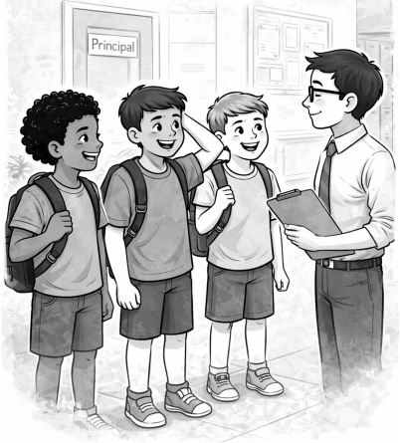

Chapter 7: Take Responsibility for Your Own Actions
Welcome to middle school—a place where you’ll gain more independence, meet new friends, learn new things, and occasionally forget homework you swore you put in your backpack. Part of growing up is learning to take responsibility for your actions. (Spoiler: this includes the good choices and the “oops… why did I do that?” moments.)

Understanding Responsibility
Taking responsibility means owning your actions, decisions, and the results—whether they’re great or not-so-great. It means raising your hand and saying, “Yep, that was me,” instead of pretending you just happened to be next to a broken pencil sharpener by coincidence.
Being responsible is a huge part of growing into a mature, trustworthy, and confident person. (Bonus: adults will start trusting you with cooler responsibilities—like group leadership or pizza-ordering duties.)

Learning and Growth
When you take responsibility, you open the door to learning and growth. Instead of thinking, “Wasn’t my fault,” you start asking, “Okay… what can I do better next time?” That mindset helps you improve, become more capable, and avoid repeating mistakes.

Building Trust and Respect
People respect someone who owns their actions. Teachers, friends, and family notice when you’re honest—especially when it’s uncomfortable. Saying, “I’m sorry, I messed up,” earns way more respect than blaming aliens for erasing your memory.
Trust grows when you show you can handle responsibility—and trust leads to better friendships, smoother group projects, and fewer “stern adult stare” moments.

Developing Self-Reflection
Taking responsibility helps you look inward and think about your actions. It helps you ask questions like:
“Why did I make that decision?”
“Would I do it again?”
“Was that the best choice, or did I just panic because someone offered candy?”
Reflecting helps you understand your values, habits, and goals. (Plus, it prevents repeat disasters.)

Overcoming Excuses
Let’s be honest: excuses are tempting. It’s easy to say:
“My Wi-Fi exploded.”
“I didn’t hear the homework assignment.”
“My goldfish was emotionally supportive, and I got distracted.”
But excuses block growth. Taking responsibility builds strength and integrity—and yes, sometimes it also builds courage, especially when you’re confessing something awkward.

Strategies for Taking Responsibility

Acknowledge Mistakes Promptly
When you realize you made a mistake, admit it sooner rather than later. Quick honesty beats a complicated cover-up. (Trust us—cover-ups almost always unravel faster than toilet paper in a hurricane.)

Avoid Blaming Others
Resist pointing fingers. Owning your decisions shows maturity—not to mention, blaming others usually makes things worse and significantly more awkward.

Apologize Sincerely
A real apology isn’t: “Sorry… BUT…” or “Sorry if YOU were offended.” Keep it honest and simple.

Make Amends
If you caused a problem, do what you can to fix it. If you knocked over someone’s supplies, help reorganize—not run away like you just robbed a bank.

Learn from Feedback
Feedback isn’t about pointing out flaws—it's about helping you level up. Treat it like a cheat code, not an insult.

Benefits of Taking Responsibility

Personal Growth and Development
Responsibility builds resilience, confidence, and maturity—basically the starter pack for becoming an awesome human being.
Improved Relationships
Accountability strengthens friendships and builds trust. People feel safe around you when they know you’re honest—even when things get uncomfortable.

Academic and Career Success
Teachers, coaches, and future employers all appreciate someone who takes responsibility. It shows reliability and integrity—skills that will help you succeed far beyond middle school.

Conclusion
Taking responsibility for your actions isn’t always easy—but it’s one of the most important skills you’ll ever learn. When you admit mistakes, learn from them, and take steps to improve, you grow stronger, wiser, and more confident.
So the next time something goes wrong, instead of panicking or pointing at the nearest innocent bystander, remember: taking responsibility shows maturity, integrity, and leadership.
And hey—mistakes don’t define you. How you respond to them does.
Own your actions, learn from them, and keep striving to be the best version of yourself.
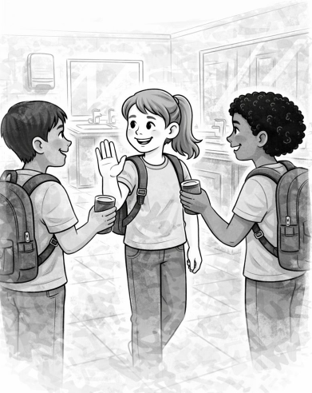

Chapter 8: It’s Okay to Say “No” to Peer Pressure
(Yes—even if everyone else is saying “Come onnnnnn!”)
Entering middle school means new experiences, new people, and new situations—including some where someone might suggest doing something questionable… like sneaking extra dessert, skipping homework, or joining a TikTok trend that definitely should’ve stayed in drafts forever.
Peer pressure can be sneaky. Sometimes it looks like encouragement (“Join the club, it’s awesome!”), and sometimes it’s just a bad idea dressed up as “fun” (“Let’s throw gummy bears at the ceiling and see if they stick!”).
The important thing to remember: Saying no doesn’t make you uncool—it makes you confident, smart, and true to yourself.

Understanding Peer Pressure

What is Peer Pressure?
Peer pressure is when people your age influence you to act a certain way, whether you actually want to or not. It can be direct, like someone asking you to do something, or indirect, like feeling left out if you don’t join in.

Basically:
If someone asks you to do something and your brain whispers, “I don’t know about this…,”
that’s peer pressure.

Two Types of Peer Pressure

Positive Peer Pressure:
Encourages you to do the right thing—like studying, joining a club, or trying out for a sport. Think: the healthy version.

Negative Peer Pressure:
Pushes you toward not-so-smart decisions—like skipping school, being unkind, or doing anything that would make your future self groan and say, “Why… just WHY?”

The Importance of Saying No

Maintaining Your Values
Your values are like your personal rulebook. If something goes against your beliefs, comfort level, or common sense, it’s okay to say no—no matter how many people are saying yes (even if they’re chanting like a pep rally).

Avoiding Harmful Consequences
Negative choices can lead to big consequences—detention, lost trust, or phone privileges disappearing faster than cookies at a school bake sale…
Saying no protects your future—and your Wi-Fi access.

Demonstrating Self-Respect and Independence

Having Your Own Voice
Saying no shows you think for yourself—not just following the group like a confused duckling. You get to choose your actions, not the crowd.

Earning Respect
People admire someone who stands up for what’s right—even if they don’t say it out loud. (Don’t worry—they’re thinking it.)
True friends don’t try to make you uncomfortable.
If someone gets mad at you for having boundaries? Surprise: That’s not a friend.

Recognizing True Friends

Supportive Relationships
Real friends won’t pressure you into doing something wrong or uncomfortable. They’ll support your choices.

Identifying Fake Friends
If someone only likes you when you do what they want, that’s not friendship—that’s manipulation with a side of drama. You deserve better.

Tips for Saying No to Peer Pressure

Be Confident
A strong, clear “No thanks” works better than a long, nervous speech followed by apologizing to the air.

Use “I” Statements
“I don’t want to.”
“I’m not comfortable with that.”
“I promised myself I'd avoid terrible decisions today.”

Suggest Alternatives
Instead of: “Let’s ditch class!”
You could say: “Or… we could pass math and then get snacks after school?”

Seek Support
If you’re feeling stuck, talk to someone—a parent, teacher, counselor, or that one friend who always has wisdom to share.

Building a Positive Support Network
Surround yourself with people who respect your choices and make you feel good about being yourself—not people who turn regular situations into episodes of a bad reality show.
Joining clubs, sports, or other activities helps you find friends who share your interests—not just your lunch table.

Conclusion
Saying no to peer pressure is a powerful skill—one that shows confidence, self-respect, and maturity. The more you practice it, the easier it gets.

Remember:
Saying no doesn’t make you weird.
It makes you strong.
It helps you stay true to who you are (and who you’re becoming).
The people who respect your choices are the ones worth keeping in your life. Stand firm, stay true to your values, and choose what’s right for you—not what’s popular for five minutes. Because in the end, being yourself is way cooler than being someone else’s idea of cool.
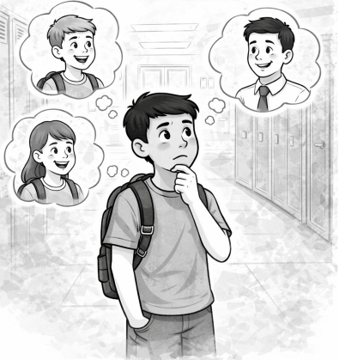

Chapter 9: Asking Yourself…“Will My Family, Friends, or Loved Ones Be Proud of Me After I Make This Decision?”
(If the answer is “…uh oh,” maybe rethink it.)
Middle school is full of choices—some big, some small. Somewhere along the way, your brain might scream, “DO NOT DO THIS!” while your curiosity whispers, “But… what if it’s fun?” Before jumping into a questionable idea—like tossing something across the cafeteria or sending a message you’ll cringe at later—pausing to ask yourself:
“Will the people who care about me be proud of this choice?”
can save you from embarrassment, regret, and possibly a parent lecture that begins with, "We need to talk."

Why This Question Matters

Guiding Your Actions
This question works like your internal GPS—except it doesn’t say “Recalculating” every time you make a wrong turn. Instead, it nudges you to consider consequences before acting, helping you avoid being the star of a story that starts: “So… you’ll never believe what happened.”

Encouraging Responsibility
Thinking about how your choices affect others helps you become more responsible and mature. In other words—you move from “I didn’t mean to!” to “I thought this through, and here’s the plan.”

The Power of Self-Reflection

Developing Self-Awareness
Self-reflection helps you understand why you do what you do. Are you making choices because you truly want to—or because someone said, “Come on, everyone else is doing it”?

Improving Decision-Making Skills
The more you pause and think (yes, even for five seconds), the easier it becomes to make smarter decisions. Over time, you won’t just be reacting—you’ll be choosing wisely. And no one regrets choosing wisely. (Except maybe choosing the salad when you really wanted the pizza.)

Practical Steps for Self-Reflection

Pause and Think
Even a short pause can prevent long-term cringe.
Before acting, take a breath and ask: “Will this make me proud—or grounded?”

Consider the Consequences
Think ahead. Will this decision lead to something positive—or something like, “Why is the principal calling home?” If it’s the second option… maybe skip it.

Align with Your Values
Your values are like personal rules—even if you haven’t written them on a glittery bulletin board. If something goes against who you want to be, it’s not worth doing.

Benefits of Asking This Question

Building Trust and Respect
When people see you consistently making solid choices, they trust you more. That means more independence, more responsibility, and fewer suspicious parent eyebrow raises.

Enhancing Personal Growth
Each time you reflect before acting, you grow—not like “my jeans don’t fit anymore” growth, but the maturity kind.

Preventing Regret
Taking a moment to think can help you avoid mistakes that stick with you—unlike the time you thought cutting your own hair was a good plan.

Encouraging Others

Leading by Example
When others notice that you make thoughtful decisions, they may start doing the same—because confidence and responsibility are contagious in the best way.

Sharing Your Experiences
Talking with friends about smart decision-making isn’t bragging—it’s leadership. And who knows? You might save someone else from a messy mistake.

Conclusion
Asking whether your family, friends, and loved ones would be proud of your choices is a simple but powerful way to guide your actions. This small question helps you build character, earn trust, and avoid regret. So next time you face a decision—big or small—stop for a second and think: Will this choice make people proud… or make them sigh dramatically?
Choose the path that reflects who you want to be. Thoughtful decisions don’t just shape your middle school experience—they shape the person you’re becoming.
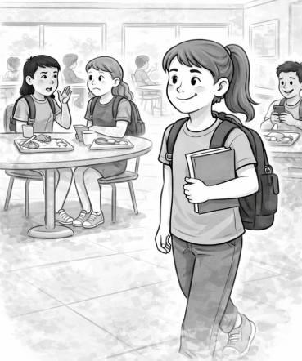

Chapter 10: Stay True to Yourself
Welcome to middle school—a place where lockers jam, friendships form, and someone always seems to forget their gym clothes. It can feel exciting, confusing, and a little like stepping into a live-action movie where everyone else already knows their lines.
Amid all this chaos, it’s normal to feel pressure to fit in, blend in, or magically transform into someone cooler, funnier, taller, or better at math. But here’s the truth: the most powerful and impressive thing you can do is simply be YOU. Trying to be someone else is like wearing someone else’s shoes—eventually, it hurts, and you walk funny.
This chapter explores why being yourself is your greatest superpower—and how doing so can help you make real friends, feel confident, and actually enjoy middle school (yes, enjoy).

Why Staying True to Yourself Matters

Authenticity Builds Trust
People can tell when you're being genuine—just like they can tell when someone says, “I love homework!” (Nice try.) When you’re real, people feel safe around you and connected to you. That’s how the strongest friendships are formed.

Avoiding Unnecessary Stress
Pretending to be someone else is basically a full-time job. It’s exhausting. It’s confusing. And honestly, you already have enough to handle—homework, extracurriculars, and remembering locker combinations should be plenty.

Promotes Self-Respect
When you stay true to yourself, you’re telling the world, “I matter.” That confidence grows over time, and before long, you’ll stand taller—not because of platform shoes, but because you genuinely respect yourself.

Embracing Your Unique Qualities

Understanding Your Strengths
Maybe you’re great at drawing, soccer, Minecraft building, or making people laugh so hard they snort. Identify your strengths—they make you who you are.

Celebrating Differences
The world would be boring if everyone were the same. Imagine a universe where everyone had the same haircut, wore the same clothes, and told the same jokes. Yikes. Celebrate what makes you different—it’s your personal brand, like a signature flavor of ice cream.

Sharing Your Passions
Whether you love reptiles, robotics, reading, or collecting random shiny rocks (no judgment), share it! Passion is contagious. You may even meet a new friend who says, “Wait—you like that too!?”

The Impact of Trying to Be Someone You’re Not

Pushing People Away
Trying to act like someone else can create awkward, surface-level friendships—like an app trial version. People want the full version: the real you.

Losing Sight of Yourself
Pretending can make you forget what you actually like. One day you’re wearing a shirt you don’t even like saying, “Do I enjoy neon green flamingos? Or...who am I?”

Short-Term Gains, Long-Term Costs
Sure, pretending might get you temporary attention. But long-term, being true to yourself builds friendships and confidence that last—way longer than a TikTok trend.

Tips for Staying True to Yourself

Reflect on Your Values
Think about what matters to you—kindness, honesty, fairness, pineapple on pizza… okay, maybe not that last one.

Be Honest With Yourself and Others
If you dislike a show everyone else loves, it’s okay to say so. (Yes, even if everyone gasps.)

Surround Yourself With Supportive People
If someone makes you feel like you have to change who you are, that’s not your person.

Practice Self-Acceptance
Nobody is perfect. You’re growing, learning, and evolving. Give yourself grace.

Building Genuine Friendships

Look for Like-Minded Individuals
Friends who get your weirdness? Those are keepers.

Foster Open Communication
Talk honestly. Listen honestly. Don’t just nod and pretend you understood when you definitely did not hear the directions.

Respect Differences
Even best friends don’t have to be clones. Differences make relationships strong—not confusing.

Conclusion
Middle school is a journey, and the best way to travel through it is as your real, amazing, sometimes awkward, always-growing self. Staying true to who you are helps you build confidence, reduce stress, and connect with friends who appreciate you—not a pretend version of yourself.
Remember: people choose to be your friend because of who you are, not who you think you should be. Your uniqueness is your power—wear it proudly. Because at the end of the day, everyone else is already taken, so you might as well be the best version of YOU.


Chapter 11: The Art of Time Management
Welcome to middle school—the stage of life where your schedule suddenly includes homework, clubs, band practice, sports, social plans, eating snacks, losing your charger, finding your charger, and occasionally…sleep. With all these new responsibilities, time management becomes your secret weapon.
Learning to manage your time isn’t just helpful—it’s what keeps you from writing an essay at 11:59 p.m., panicking, and Googling, “How long is one paragraph supposed to be?” This chapter will help you understand why time management is important and give you practical strategies to manage your time like a pro.

Why Time Management Matters

Reducing Stress
When you manage your time well, you avoid last-minute chaos—also known as the Great Homework Panic of Sunday night. Planning ahead helps you feel calmer, more in control, and less like you're sprinting from one thing to another with your backpack half open.

Improving Academic Performance
Time management gives you the space to study, finish assignments, and truly understand what you're learning—not just cram it five minutes before class and hope it sticks. Spoiler: it doesn’t.

Enhancing Social and Emotional Well-Being
Good time management means you can get everything done and still have time to hang out with friends, play games, unwind, or even stare into the fridge when you’re not hungry. Balance just makes life better.

Developing Time Management Skills

Prioritizing Tasks
Not all tasks are equal. Some are important (like studying or finishing homework), while others…well, sorting your Pokémon cards alphabetically can probably wait. Focus on what matters most first.

Setting Goals
Goals help you stay focused. For example:
Big task: Write a three-page essay
Smaller steps: Create outline → Write one page → Reward yourself with snacks → Write another page → More snacks
Breaking things down makes everything feel more doable (and snack-rewardable).

Creating a Schedule
Use a planner or digital calendar to write down your schedule. If you try to remember everything in your head, one of two things will happen:
You’ll forget.
You’ll really forget.
Schedules help you keep track of deadlines and make sure nothing sneaks up on you.

Strategies for Effective Time Management

Make a To-Do List
Lists are your friend. Write down everything you need to do, then check off each task one by one. Those checkmarks give you a tiny burst of satisfaction—like winning a mini victory.

Avoid Procrastination
Waiting until the last minute feels fun…until it doesn’t. Start early and break tasks into smaller parts so they don’t feel overwhelming. Future-you will thank present-you.

Take Breaks
Your brain is powerful, but it also needs snacks and rest. Short breaks help you stay focused and avoid burnout. Just make sure your 10-minute break doesn’t somehow turn into two hours of scrolling funny cat videos.

Benefits of Good Time Management

Developing Good Habits
Practicing time management helps you build habits like planning, prioritizing, and staying organized. These habits will benefit you for years—even in high school, college, and beyond.

Enhancing Self-Discipline
Managing your time requires discipline. With practice, you’ll get better at staying focused, resisting distractions, and sticking to your plan—even when video games or group chats are calling your name.

Achieving a Balanced Life
Time management gives you space for school, hobbies, relaxation, and relationships. When everything has a place, life feels less hectic and more enjoyable.

Tips for Improving Time Management

Start Early
Begin assignments when you get them—not the night before they’re due.

Stay Organized
A clean workspace means fewer distractions (and fewer missing papers that “mysteriously disappeared”).

Reflect and Adjust
If something isn’t working, tweak your schedule and try again. Improvement takes practice—not perfection.

Conclusion
Time management is a key skill for success in middle school and beyond. By planning ahead, prioritizing wisely, and creating a schedule, you can reduce stress and bring balance to your life. It might take some practice, but over time, you'll master the art of managing your time effectively.
Remember: time management doesn’t make life boring—it actually makes room for everything that matters, including fun, rest, personal growth, and maybe even finishing your homework before dinner. Now that’s progress!
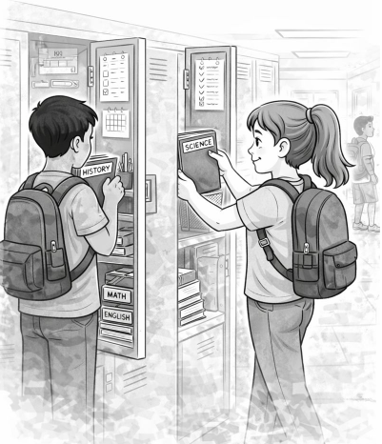

Chapter 12: Learning to Stay Organized
Middle school comes with a lot of new responsibilities—homework, projects, sports, clubs, and the endless quest to track down your charger, your lunch, or that one elusive pencil that seems to vanish faster than socks in a dryer. Staying organized isn’t just about neatness—it’s about making sure your life doesn’t feel like a daily scavenger hunt. This chapter will explore why staying organized matters and give you practical tips to keep your schoolwork and materials in order (without losing your mind—or your backpack).

Why Staying Organized Matters

Enhancing Academic Success
When your materials are organized, you'll be able to find assignments, notes, and handouts exactly when you need them—without digging through a pile of crumpled papers that could double as a small fort. Knowing where everything is makes studying for tests and completing projects much less stressful, and your grades will thank you.

Reducing Stress
A messy locker, backpack, or digital workspace is basically a stress magnet. You know that feeling when you’ve done the homework but it’s nowhere to be found? Yeah, staying organized can prevent that awkward “uhh… ooh” moment in class.

Saving Time
The less time you spend looking for things, the more time you'll have for actual learning—or for more important stuff, like playing video games, reading comics, or planning the ultimate snack schedule.

Developing Organizational Skills

Creating Subject-Specific Folders
Use separate folders for each subject. Think of it like giving each subject its own little home instead of letting them fight for space in your backpack like reality TV contestants.

Regularly Reviewing Materials
Take a peek through your locker, backpack, and digital files every so often. This ensures nothing is lost, forgotten, or mysteriously eaten by your backpack monster.

Keeping a Planner
A planner is your middle school best friend—write down assignments, tests, and activities. If you forget it, it won't nag you, but it will silently judge your life choices.

Practical Organization Strategies

Use Color Coding
Assign each subject a color. Math = blue, English = red, Science = green.

Label Everything
Label your folders, binders, and notebooks. This way, if you accidentally leave something behind, it might actually find its way home instead of becoming “lost property forever.”

Maintain a Clean Workspace
Keep your desk or locker tidy. A clean space = a clear mind. Or at least fewer papers hiding that you swear you just had a second ago.

Organizational Skills for Digital Learning

Create Digital Folders
Organize your files online just like you do your physical stuff. Think of it as giving your computer a mini filing cabinet, instead of letting it live in chaos.

Back Up Your Work
Always save extra copies. Computers sometimes have mood swings, and your essay disappearing is not part of the curriculum.

Use Digital Tools
Try digital planners, calendar apps, or to-do lists. They won’t nag you…much.

The Benefits of Staying Organized

Improved Focus
When your materials are organized, you'll actually be able to find what you need and spend more time learning instead of searching for that one lost worksheet.

Greater Responsibility
Being organized shows you’re responsible. It’s like saying to your teachers: “I’ve got this…mostly.”

Enhanced Preparedness
Staying organized ensures you’re ready for class, tests, and surprise pop quizzes that somehow happen when you least expect them.

Tips for Maintaining Organization

Set a Routine
Make organizing a regular habit. Even 10 minutes a day can prevent your backpack from resembling a tornado aftermath.

Stay Disciplined
Put things back where they belong. It’s not just neat—it’s your insurance against losing your homework to the “void of forgotten assignments.”

Seek Help if Needed
If organization feels impossible, ask a teacher, parent, or friend for tips. Sometimes it takes a team to tame the chaos monster.

Conclusion
Staying organized is key to middle school success. It saves time, lowers stress, and helps you focus on what really matters—learning, growing, and maybe even finding that missing homework before the teacher notices. With subject-specific folders, planners, and a bit of discipline, organization can become second nature. So embrace it now and watch your school life go from chaos to…well, slightly more manageable chaos.
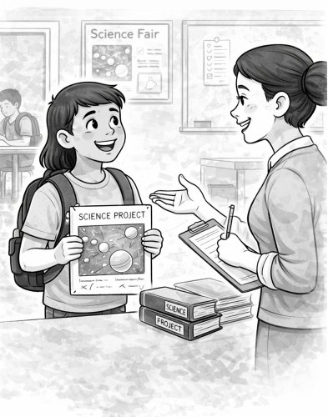

Chapter 13: Be Open to Criticism or Feedback
Middle school can sometimes feel like riding a roller coaster while everyone shouts directions from the sidelines. One of the most valuable skills you'll develop is learning to accept—and grow from—criticism or feedback. While it might sting a little, like when someone tells you your science project looks “interesting” (code for “what is that?”), feedback is actually a golden opportunity to improve and succeed.

Embracing Growth Opportunities
Criticism and feedback are like secret treasure maps—they show you where to go to level up your skills. When someone offers feedback, they’re giving you a peek at how to make your work better, even if it feels like a mini plot twist in your middle school adventure. Embracing it helps you see things from a fresh angle and sharpen your skills faster than a pencil before math class.

Understanding Different Perspectives
Everyone has their own unique viewpoint. Receiving criticism is like looking at your work through a different pair of glasses—sometimes rose-colored, sometimes blurry, and sometimes making you think, “Wait, did they really just say that?” Understanding other perspectives helps you build empathy and respect for diverse opinions.

Building Resilience
"Learning to accept criticism builds resilience. It’s like leveling up in a video game: each ‘Hmm, try this differently’ moment earns you more skill points. Soon, you’ll face setbacks with the calm of someone who just spilled their backpack all over the floor… again."

Strengthening Relationships
Being open to feedback shows maturity (and secretly makes you look like a genius to teachers, peers, and mentors). People appreciate it when you listen and genuinely try to improve. It helps you build strong connections that support your growth—just don’t start expecting a standing ovation every time you nod politely.

Improving Performance
Constructive criticism is basically a cheat code for doing better next time. Think of it as a roadmap to success: apply the advice, tweak your approach, and level up. Before you know it, your next project or presentation could be so good that even your teacher forgets the last time you accidentally glued your fingers together.

Overcoming Fear of Failure
Criticism can be scary, but feedback is a tool, not a punishment. Embracing it shows you that mistakes are just stepping stones to improvement. Once you get used to this, taking risks—like trying out for the school play or answering a tricky question in class—becomes much less intimidating.

Strategies for Accepting Feedback
Listen Attentively – Give your full attention. Don’t zone out while mentally planning your lunch or the next TikTok dance.
Seek Understanding – Ask questions if something isn’t clear. (“Wait, do you mean I should actually write more than one sentence?”)
Thank the Person – Even if it stings a little, a polite “thanks” goes a long way.
Reflect and Apply – Take the feedback seriously and think about how to use it to improve. Think of it as a DIY upgrade kit for yourself.
Follow Up – Show that you’ve applied the feedback—it proves you’re serious about growing, not just pretending to be.

Benefits of Being Open to Feedback
Personal Growth – Helps you develop resilience, adaptability, and critical thinking. Basically, you become the middle school version of a wise wizard…minus the robe and wand.
Academic Success – Improves study habits, writing, and understanding of subjects. You might even start enjoying math…okay, maybe not that far.
Professional Development – In the future, being able to accept feedback makes you look mature and capable—your teachers will be bragging about you at retirement parties.

Conclusion
Being open to criticism or feedback is one of the smartest moves you'll ever make. It helps you learn faster, improve quicker, and build better relationships—without turning into a robot who just nods all the time. Remember, feedback doesn't define your worth; it’s a way to level up, rack up experience points, and become the best version of yourself. Take it, use it wisely, and watch yourself crush it in middle school and beyond… even if your first science project still looks like a mysterious blob.

In Closing
Middle school is more than just a new building, new teachers, and new classes—it’s a journey that helps you discover who you are and who you want to become. Each chapter in this guide has given you tools to navigate that journey with confidence, courage, and purpose.
As you move forward, remember the importance of making new friends while still appreciating the old ones who have been there for you. Don’t be afraid to step out of your comfort zone—trying new things and joining after-school activities can open doors you never knew existed (and maybe even reveal hidden talents you didn’t know you had).
Along the way, your voice matters. Learning to be assertive and advocate for yourself will help you build strong relationships and stand up for what you need. And while social media can be fun, limiting your screen time helps you focus on real-life moments that matter most—like laughing with friends, enjoying your hobbies, or finally figuring out how your locker combination works before the bell rings.
Nobody is perfect, and mistakes will happen. What counts is your willingness to take responsibility for your actions and grow from them. When you face tough choices, trust your values and ask yourself: “Will my family, friends, or loved ones be proud of me after I make this decision?”—that simple question can guide you toward choices you’ll be proud of too.
Always remember to stay true to yourself. You don’t need to act like someone else to fit in. The world needs your unique strengths, ideas, and personality—yes, even the quirky ones.
Middle school can get busy—sometimes really busy—so mastering time management and staying organized will help keep stress low and success high (plus, it might save you from finding crumpled homework at the bottom of your backpack two months later). One of the biggest lessons you’ll learn is how to accept feedback and criticism with an open mind—because that’s how you grow stronger, smarter, and more prepared for whatever comes next.
As you head into this new chapter of your life, know that you already have everything you need to thrive. Be brave, be kind, be curious, and most importantly—be you. Your middle school journey is just beginning, and the choices you make now will help shape the amazing person you’re becoming.
You’ve got this. Keep going—and enjoy the adventure ahead.

